Nithin S
221IT085

IT150 Class Assignment

1. Implement a system to manage students in an organization, categorizing them into different departments
like Engineering, Management, Arts, Medical each with specific qualifications and common attributes.
Use all the key concepts of OOPs which you have and implement using C++. Minimum 5 Concepts to be
used.
Note: (i) Use as many concepts as possible
(ii) Mention the features/ concept used along with the coding

CODE

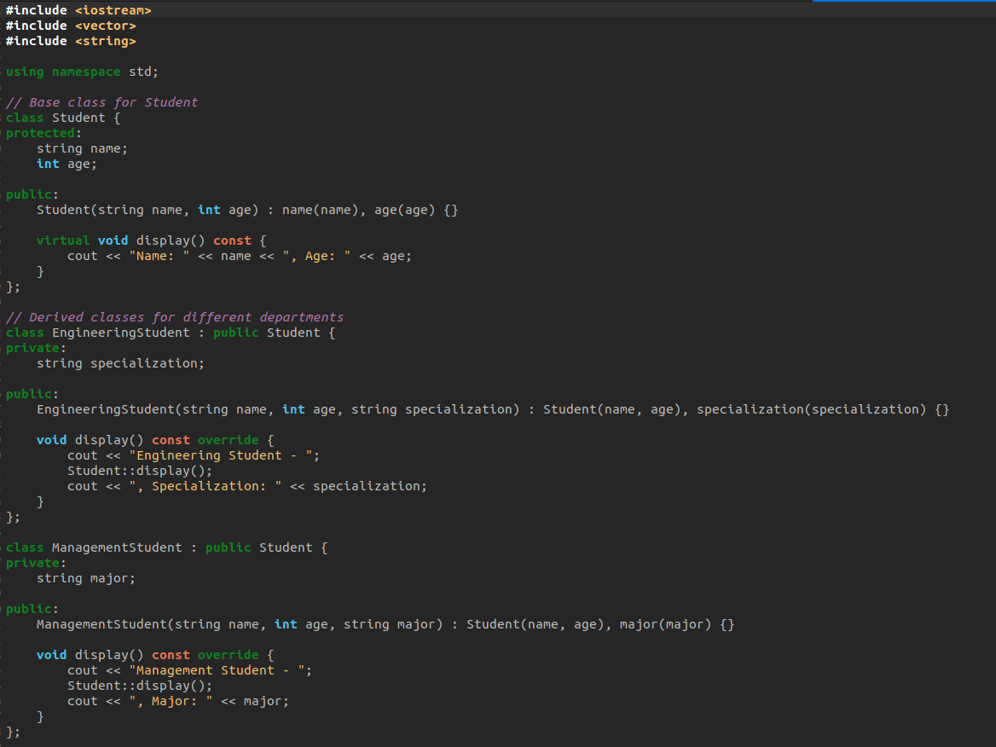

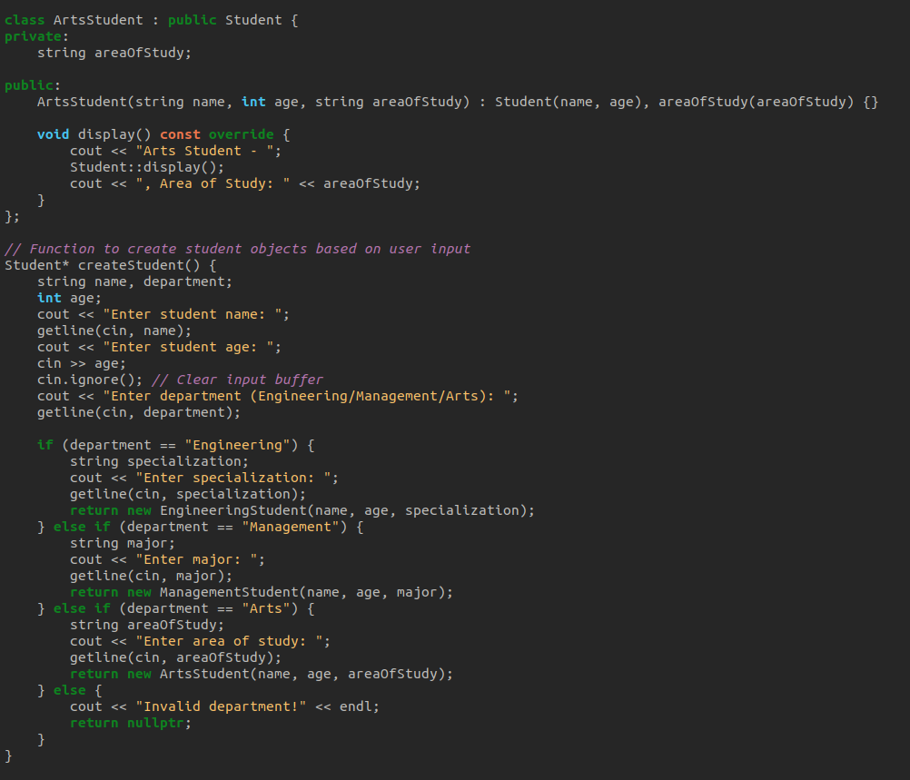

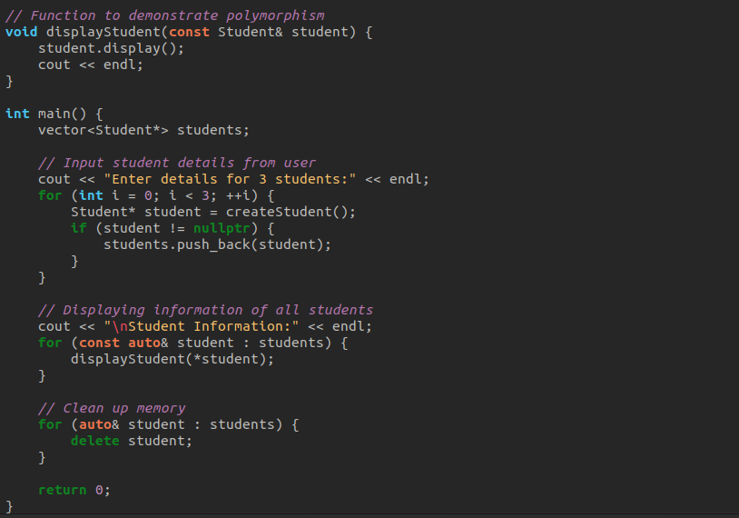

In this implementation:

Classes: Various classes are defined such as Student, EngineeringStudent, ManagementStudent, and ArtsStudent.

Inheritance: Derived classes EngineeringStudent, ManagementStudent, and ArtsStudent inherit from the base class Student.

Polymorphism: The display() function is marked as virtual in the base class Student and overridden in derived classes, allowing polymorphic behavior. Also, the displayStudent() function demonstrates polymorphism by accepting a reference to a Student object but can display information of any derived class.

Encapsulation: Data members of the Student class are encapsulated by making them protected, accessible to derived classes but not directly accessible from outside the class.

Abstraction: The implementation hides the internal details of each department's student class, providing a simple interface for displaying student information.

Output

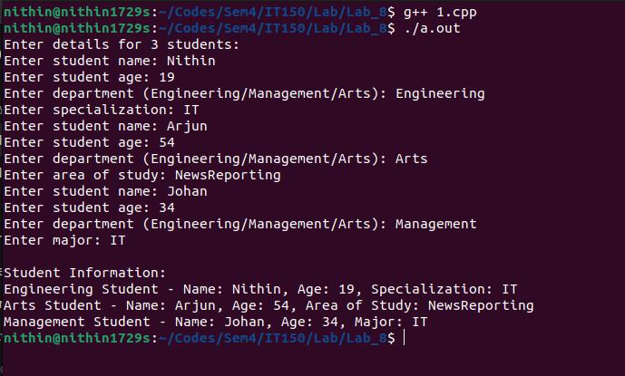

2. Write a C++ code to design a simple snake game with necessary functions and parameters. The following
to be considered during coding:
a. handle user input,
b. update the game logic,
c. display the game screen.
Follow the below Rules to Play Snake Game:
✓ Don’t hit a wall and don’t bite your own tail.
✓ Crashing into a wall or your tail will end the game immediately.
✓ 1 point will be added to the player’s score for eating the fruit (#).
✓ The player’s total score is calculated based on the number of fruits the snake consumed.
✓ The length of the snake will be increased after eating the fruits.
✓ Use w, a, s, d to move the snake.

CODE

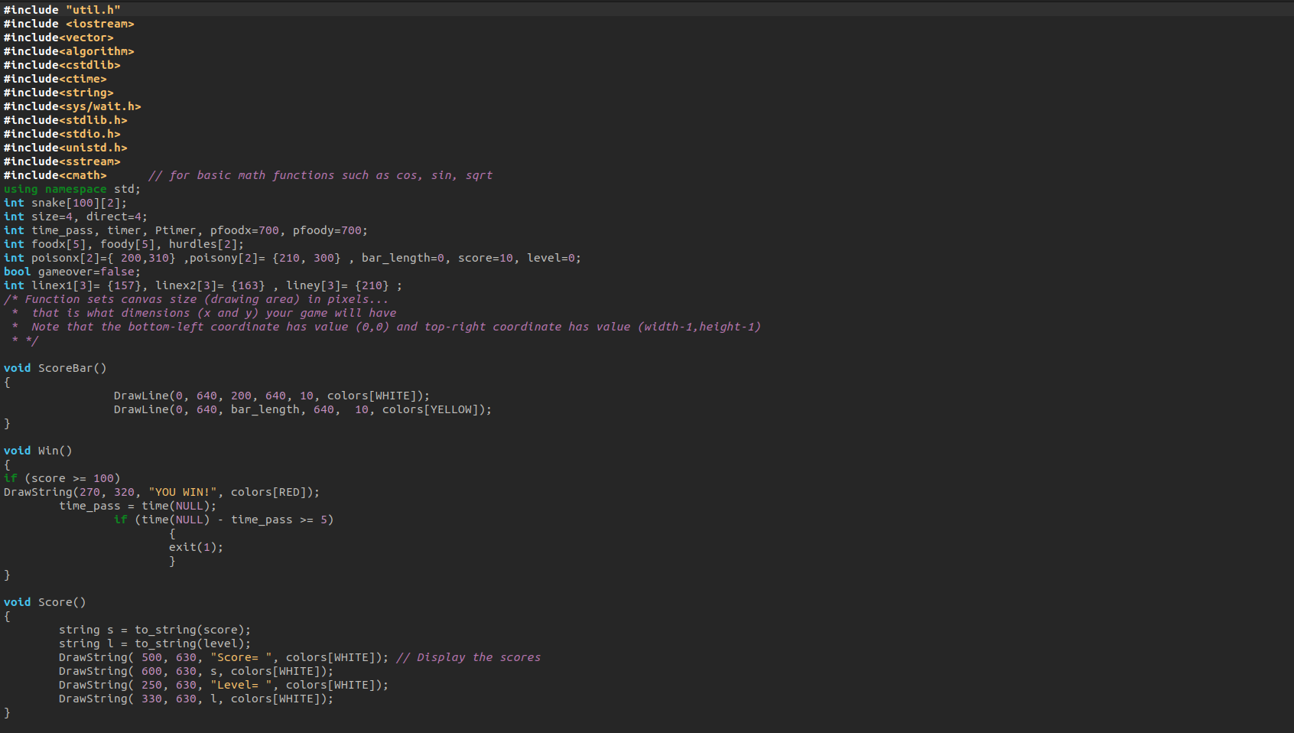

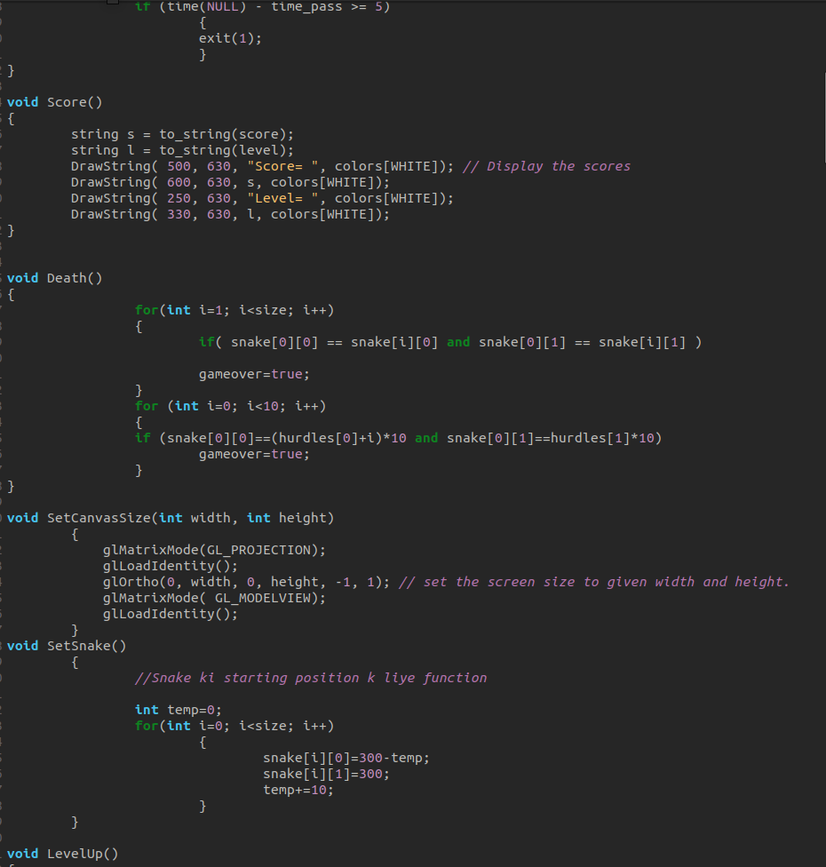

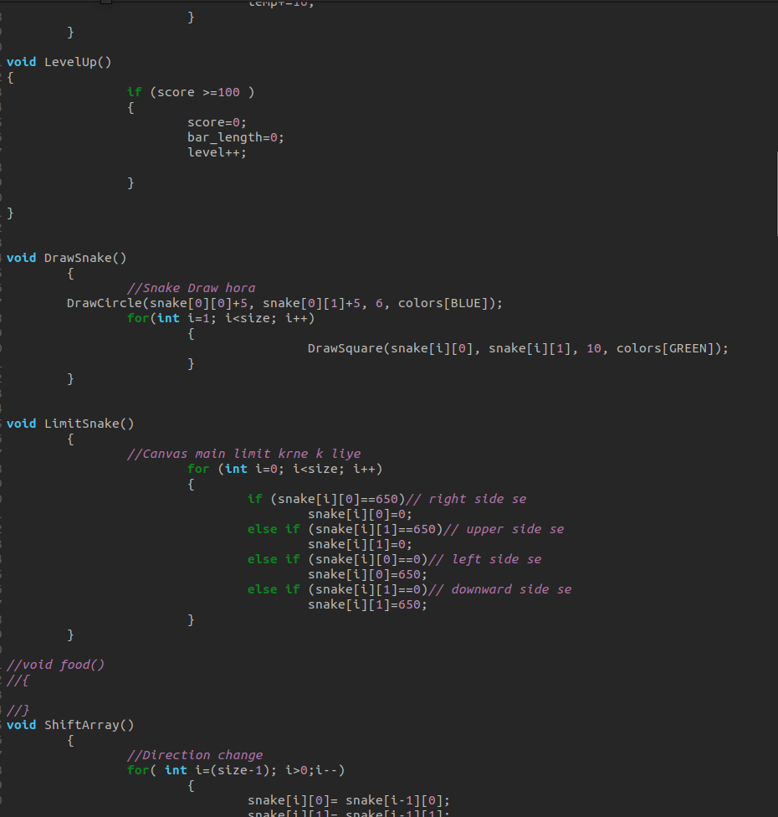

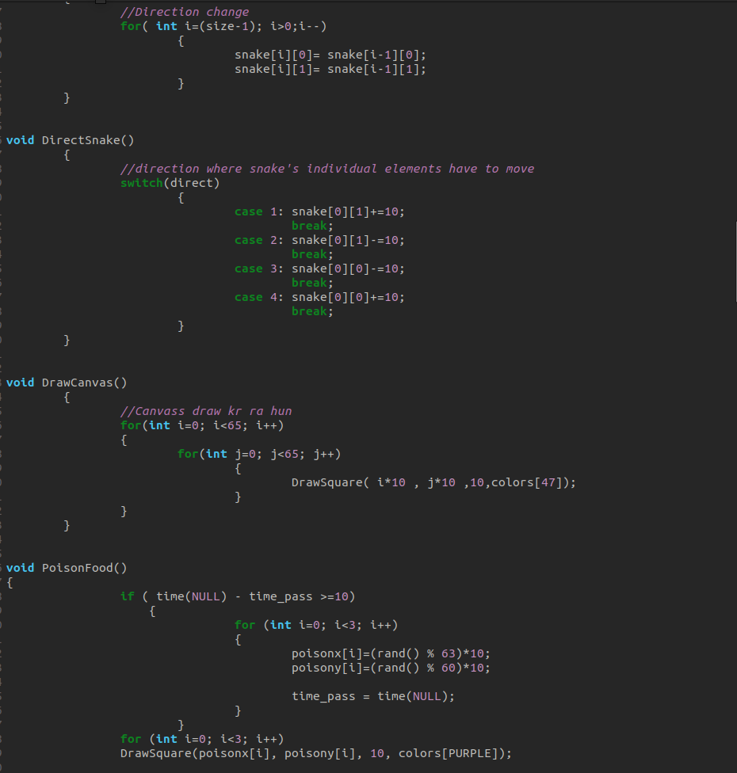

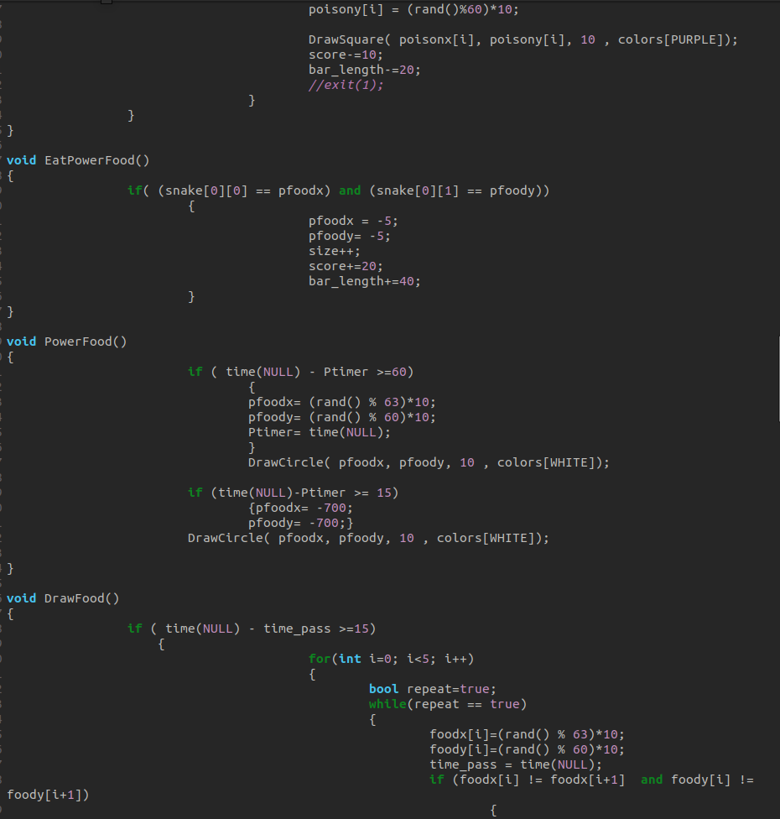

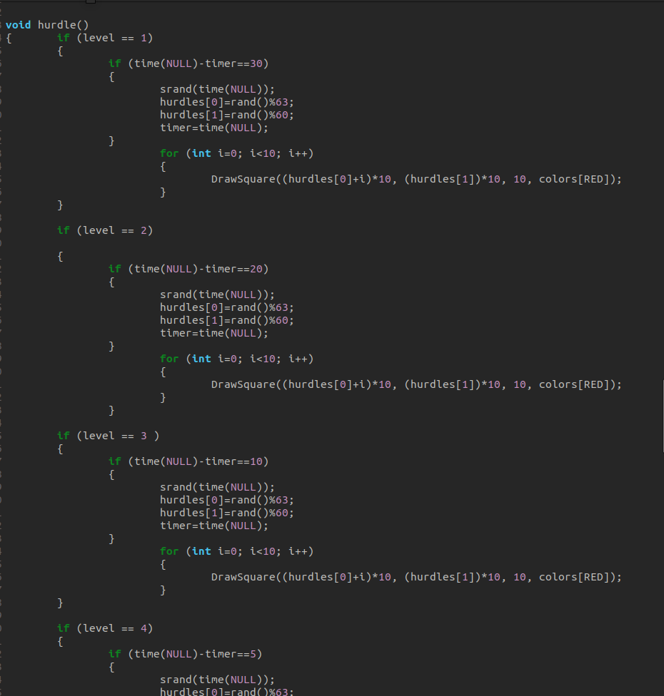

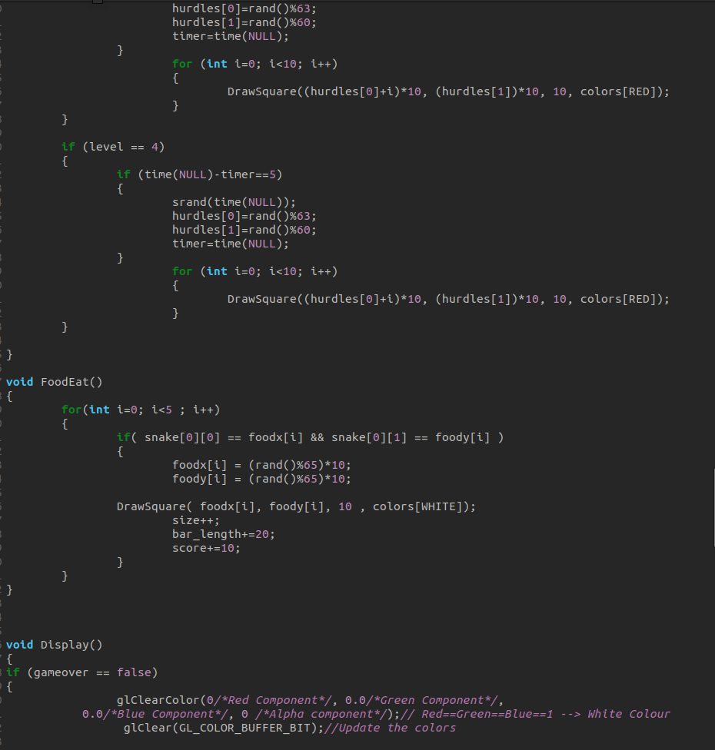

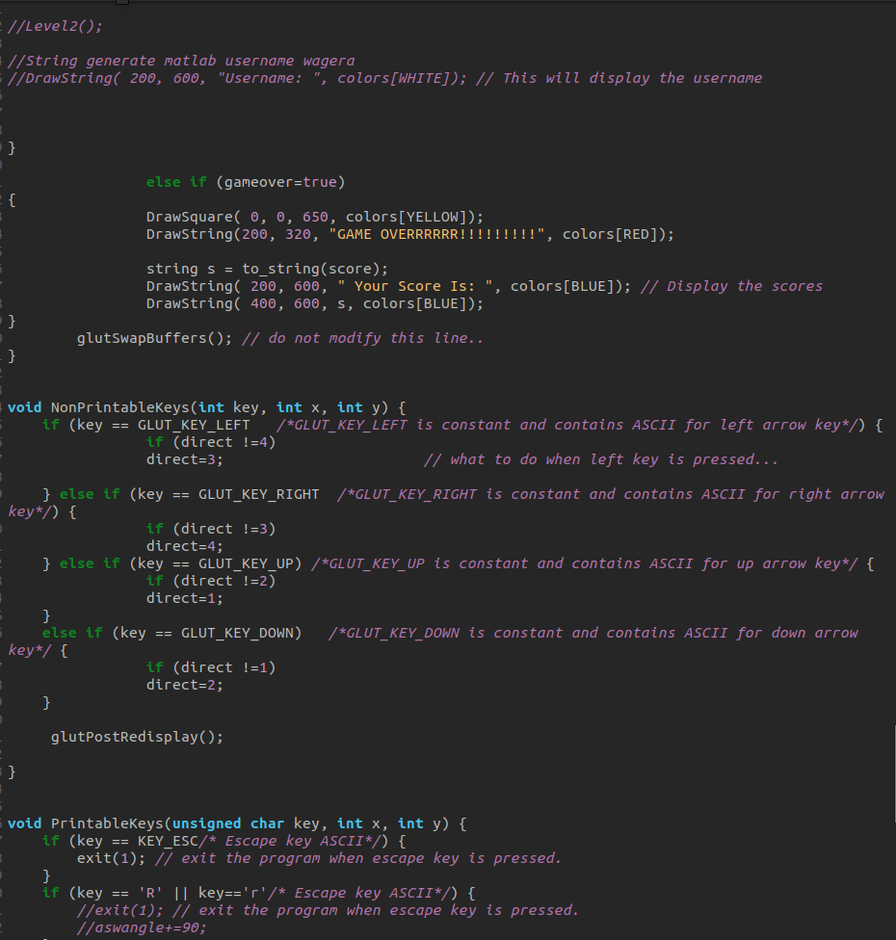

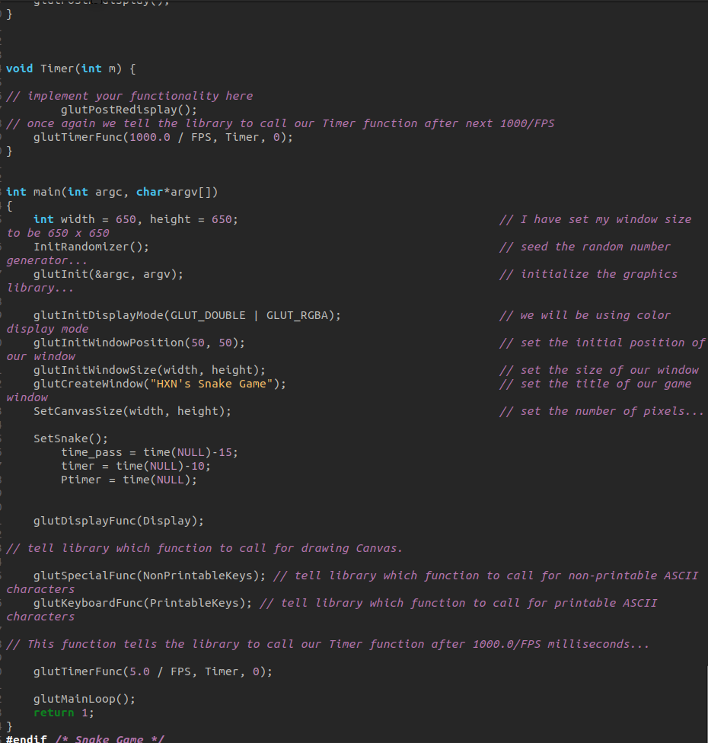

OUTPUT

